Building Public Trust Around Green Infrastructure
By installing aesthetically pleasing, publicly visible green infrastructure in your community, the local Green Team or Environmental Commission can begin generating support for investing in larger green infrastructure projects in the future. Green infrastructure can provide economic, environmental, community, and public health benefits. Green infrastructure can help improve public health by reducing pollution in rivers and streams, preventing illnesses in swimmers and boaters.

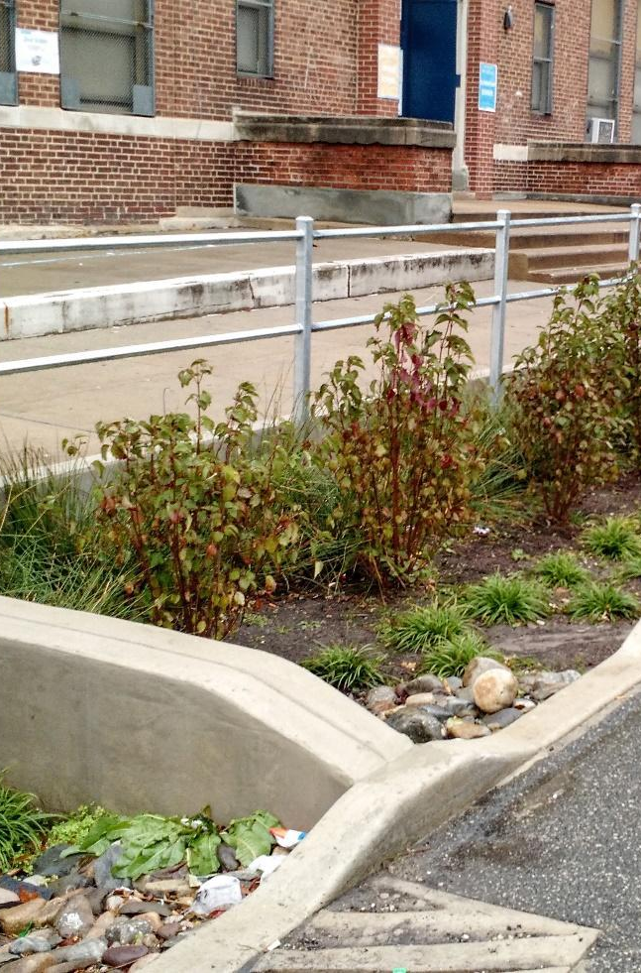
Green infrastructure describes stormwater management strategies that enable stormwater and melting snow to soak into soils near where they fall or be captured for a beneficial re-use, such as irrigation or flushing toilets. Keeping runoff out of the storm sewer system improves water quality and minimizes localized flooding.
In addition to meeting stormwater management goals and bolstering resilience to climate change, green infrastructure can also impact health concerns by reducing urban heat island effects. Some green infrastructure types, like roadway tree planting, can create and maintain green space that benefits air quality and allows community members to spend more time in and near natural and green spaces. A 2009 analysis, Towards a Better Tomorrow: Street Trees and Their Values in Urban Areas, estimated that an urban street with street trees has a 60% reduction in street level particulates compared to an urban street with little or no street trees. Another study, Children living in areas with more street trees have lower prevalence of asthma, found that a higher density of street trees were associated with lower asthma rates among children in New York City.
Bonsall School stormwater planters in Camden, New Jersey. Credit: Camden County Municipal Utilities Authority.
For more information on Green Streets, please read our recent reports on Planning for Green Streets, Funding Green Streets, and Green Streets Case Studies at: www.jerseywaterworks.org/resources/

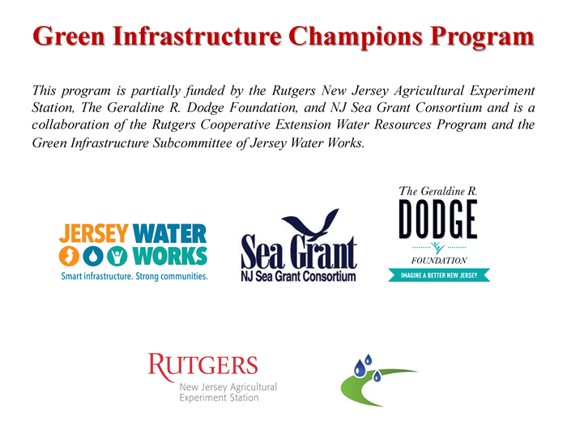


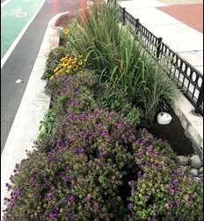

Washington Street Improvements
Hoboken, New Jersey is a densely populated city located directly on the Hudson River. Approximately 70% of the city is located within a FEMA Special Flood Hazard Area that is vulnerable to localized stormwater flooding. To address concerns about flooding from stormwater runoff, the city incorporated green streets elements into a redesign of Washington Street, Hoboken’s “main street.”
In 2013, the city installed 15 rain gardens along Washington Street (see photo to the right). In addition to capturing stormwater runoff, the rain gardens beautify Washington Street, and the curb bump-outs that contain the rain gardens provide the added benefits of calming traffic and shortening the crosswalk to improve pedestrian safety.
Hoboken took a proactive approach from the outset of the project to educate residents and address their concerns about green streets. Town halls were held to listen to concerns, gather feedback, explain the benefits of the redesign, and discuss alternatives.

Green Infrastructure Champions Program
Green Infrastructure Champions are trained volunteers who are key players in implementing green infrastructure as a stormwater management approach town by town in New Jersey.

Learn more

Scan this QR code to learn more about the Green Infrastructure Champions.

Scan this QR code to learn more about green infrastructure through the New Jersey Green Infrastructure Municipal Toolkit.
A rain garden installed along Washington Street, Hoboken, New Jersey. Credit: Hoboken, NJ.
Space Reserved for Local Logos/Contact Information:

