Green infrastructure describes stormwater management strategies that enable stormwater and melting snow to soak into soils near where they fall or be captured for a beneficial re-use such as irrigation or flushing toilets. Keeping runoff out of the storm sewer system improves water quality and minimizes localized flooding.
Green streets are the effective use of multiple types of green infrastructure within the public right-of-way to capture and treat stormwater runoff from impervious surfaces while keeping streets accessible to all users. Some green infrastructure types that can be considered for green streets projects include: rain gardens or bioretention systems (gardens designed to filter and store water), porous pavement (surfaces that allow water to percolate into the soil), street trees, and bioswales (vegetated channels designed to convey and infiltrate stormwater). Using different green infrastructure options can generate the greatest social, economic, and environmental benefits.
For more information on Green Streets, please read our recent reports on Planning for Green Streets, Funding Green Streets, and Green Streets Case Studies.
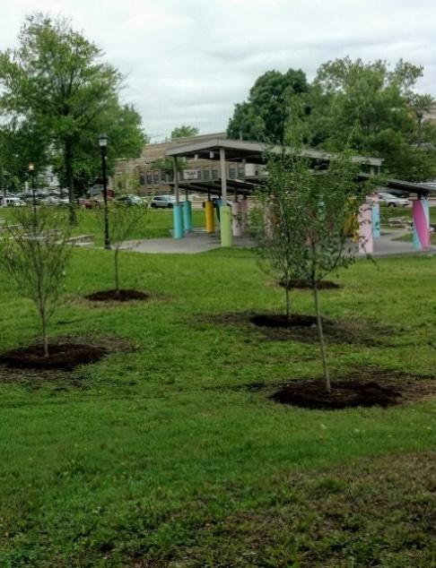
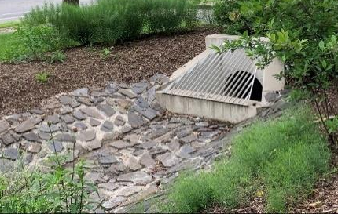
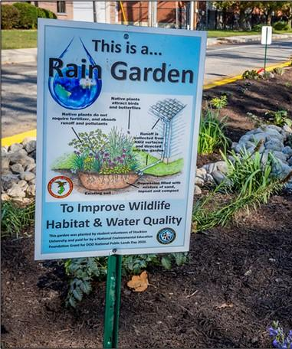
Street trees at Dudley Grange Park in Camden, New Jersey. Credit: Camden County Municipal Utility Authority.
Kemble Park bioswale with trash rack and riprap in Philadelphia, Pennsylvania. Credit: E&LP, Inc.
Rain garden with public education signage in Sea Girt, New Jersey. Credit: Mark C. Olsen.
Using Green Infrastructure to Support Community Goals
Designing green infrastructure is an interdisciplinary effort. It is important for planners, engineers, landscape architects, the public, and elected officials to work collaboratively to identify potential obstacles that may arise throughout the life of the project. Green infrastructure can help meet multiple community goals since it provides social and economic benefits to the community in addition to environmental benefits. According to Irina Wen, Ph.D., lead clinician at the Military Family Center at NYU Langone Health, in a 2017 article from NBC News, “[nature] reduces cognitive fatigue and stress and can be helpful with depression and anxiety.”



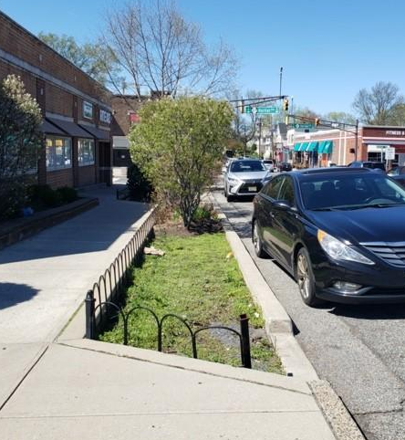

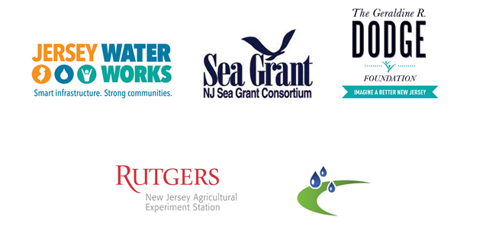
Green Infrastructure Champions Program
Green Infrastructure Champions are trained volunteers who are key players in implementing green infrastructure as a stormwater management approach town by town in New Jersey.

Rain garden with curb bump-out installed as part of Highland Park streetscape improvements. Credit: Highland Park, NJ.
Borough of Highland Park Community Green Infrastructure
In 2012, Highland Park embarked on a significant streetscape project to improve the pedestrian experience along its main thoroughfare, Raritan Avenue, to meet residents and government officials’ goal of creating an environmentally, economically, and socially sustainable borough at the forefront of addressing sustainability issues.
The borough partnered with Main Street Highland Park, a local nonprofit community development organization, to work collaboratively on including rain garden designs in already planned infrastructure upgrades. The design used curb bump-outs to create space to install rain gardens (photo to the right) but accommodated them without losing parking spaces or changing the road width along the side streets.
Main Street Highland Park helped the borough obtain a Downtown Business Improvement Zone loan and a Community Development Block Grant and the New Jersey Department of Transportation provided significant funding for the streetscape improvements.
Space Reserved for Local Logos/Contact Information:
Learn more

Scan this QR code to learn more about the Green Infrastructure Champions.

Scan this QR code to learn more about green infrastructure through the New Jersey Green Infrastructure Municipal Toolkit.

