{Name} Stormwater Authority
Frequently Asked Questions

What is a Stormwater Authority and what will it do?
{Name} Stormwater Authority will be a local government agency that has three related jobs:
 | 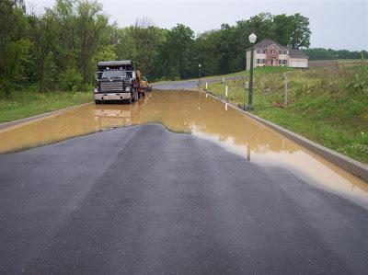
Guard the purity of the waterways that provide drinking water | Protect people, property, and roads from flooding. | Ensure waterways are clean enough to enjoy and for wildlife to survive.

What do water pollution and floods have in common?
All floods and most polluted waterways have one thing in common: stormwater runoff.
When rain falls or snow melts faster than it can soak into the ground, the runoff ends up in local waterways. When more runoff reaches these waterways than they can hold, they flood.

Lorem ipsum dolor sit amet, consectetur adipiscing elit. Suspendisse tristique consectetur efficitur. Aliquam sagittis mollis felis vitae sollicitudin. Vivamus nec porttitor est.

Stormwater runoff isn’t just muddy, it’s dirty, too. Water running off streets and parking lots carries chemical fertilizer, oil, animal waste, and trash into waterways.  It’s not very concentrated -- but there is a lot of it. Stormwater runoff is the fastest growing type of water pollution in Pennsylvania. | 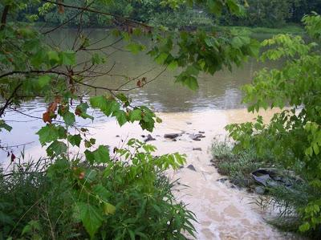

How will {name} Stormwater Authority prevent pollution and floods?
{Name} Stormwater Authority will invest in projects that control stormwater runoff. Here are a few examples:
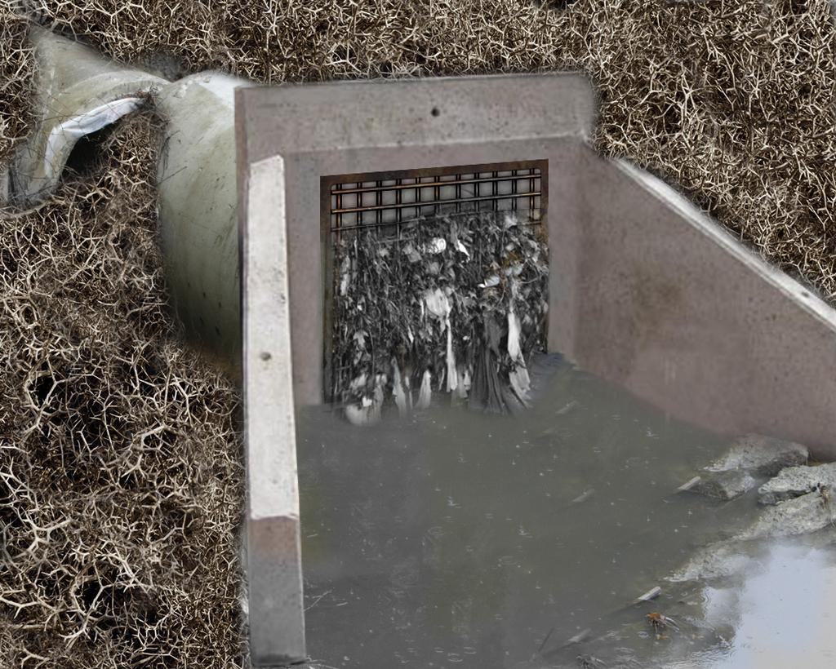 | 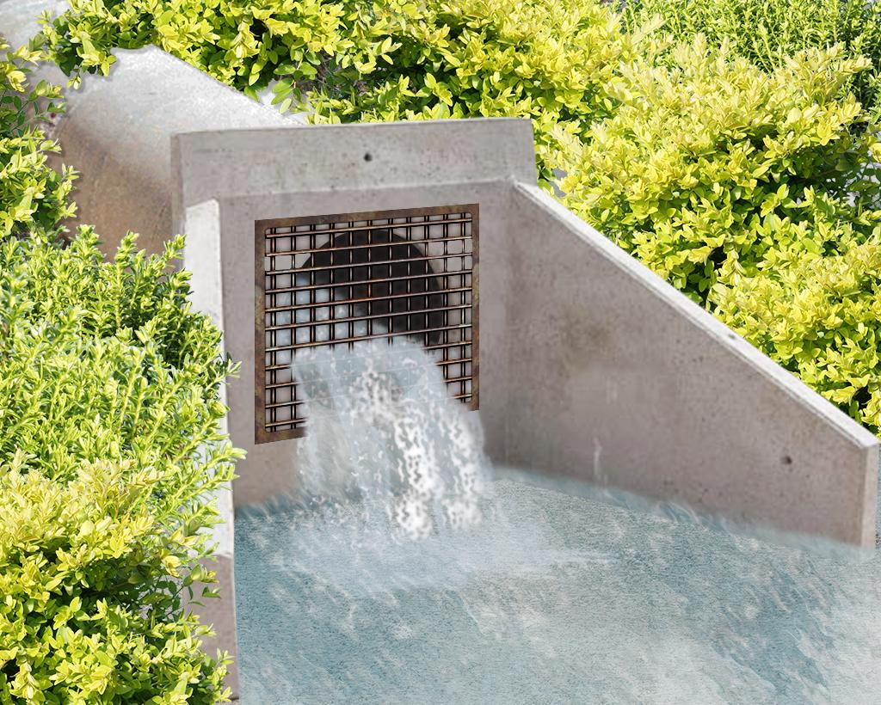
Current conditions: Storm sewer pipes are clogged, broken, or corroded, so they handle less water runoff. | Improved stormwater management: Storm sewer pipes can handle larger volumes of water runoff, reducing pollution and floods.
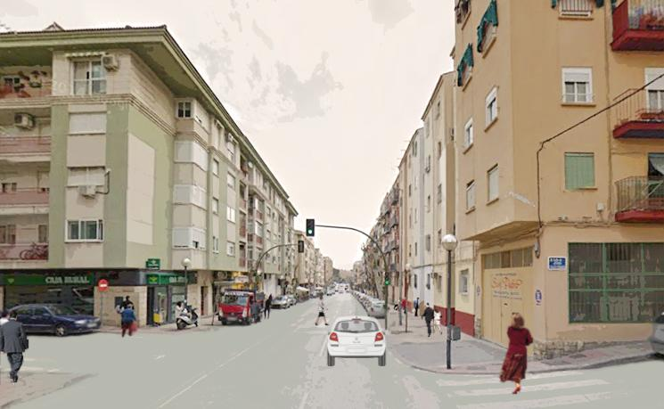 | 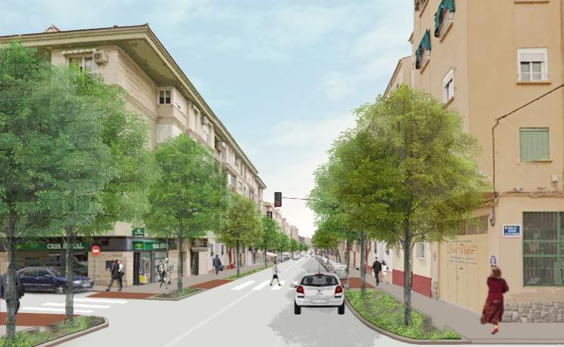
Current conditions: Rain falls onto streets and sidewalks. Most of it becomes runoff. | Improved stormwater management: Rain falls into trees and other green areas, so less of it becomes runoff.
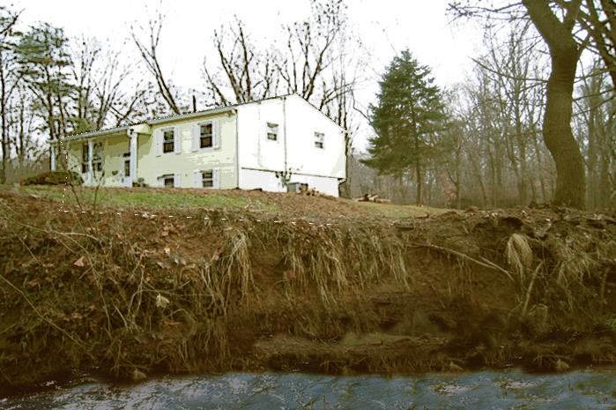 | 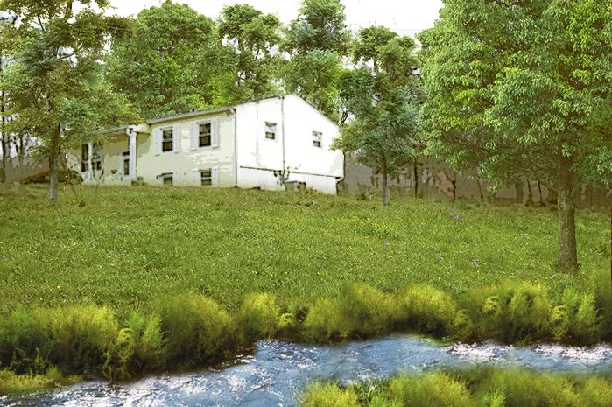
Current conditions: Eroding streambanks fill streams with mud, and these streams flood more quickly. | Improved stormwater management: Restored stream banks retain their soil and the streams flood less often.
{Name} Stormwater Authority will achieve the following goal over the next five years:
- Replace and improve xx miles of storm sewer pipe
- Restore XX acres of eroded shoreline
- Plant XX trees

How much will these investments cost me? How will you calculate my fair share?
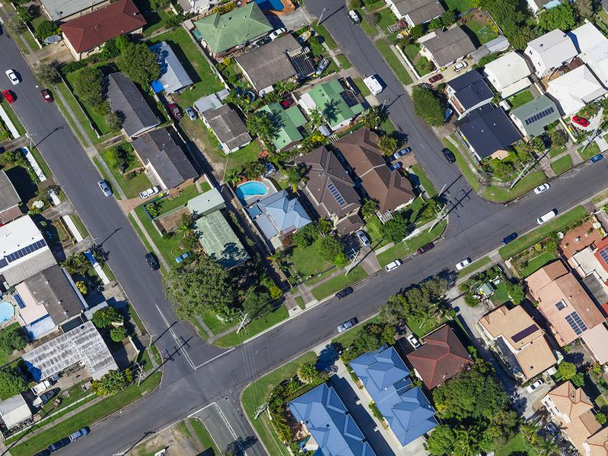
The average fee works out to about ${some amount} per household per month. It is low because all properties pay it. The small amounts add up. The total will be enough to make real investments that will make a difference.
Fees can be flat by category, or we can calculate each individual property’s fee using a formula that accounts for the size of the property and the amount of hard surfaces – pavement, asphalt, roofs – that cause water runoff.

Why is this a fair way to calculate the fee?
This is fair because properties that create more stormwater runoff pay more, and properties that create less stormwater runoff pay less.

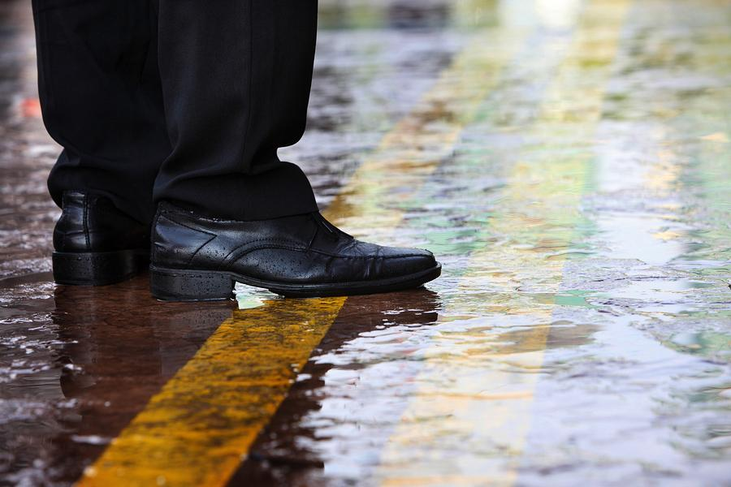
I don’t have any stormwater runoff problems on my property. Do I still pay the fee?
Yes. Even if rainwater leaves your property without causing problems for you, that runoff may cause a problem for someone else.
Every property benefits from local government services. All developed properties contribute to the problem, even in a small way. That means we have to work together and contribute to the solution.

Why is a new program necessary to pay for this?
It is necessary because the problem has grown too big to deal with any other way. As we have built roads, homes, commercial building, and parking lots, the amount of water runoff entering our stormwater system has grown much faster than the budget for this system.
We now have more miles of storm sewer pipes to maintain, more eroded stream banks to restore, and more trees to plant than we can keep up with using the current funding sources.
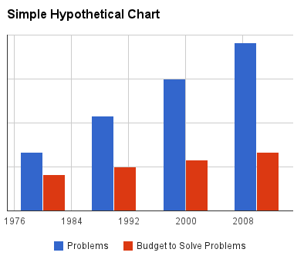

What safeguards are in place to ensure the money will be invested as promised?
Under provisions of the Municipality Authorities Act, authorities must charge rates that are reasonable and uniform and related to the service provided. The authority must use the funds on projects related to the official mission and purpose. In this case, that is stormwater management to prevent pollution and floods.
How is it legal for {local government} to do this?
Recognizing that Pennsylvania localities face increasing pressure to manage stormwater and protect residents from floods and pollution, the state legislature passed Act 68-2013 in July, 2013. This law authorizes localities to create new stormwater authorities, or add stormwater responsibilities to any existing authorities that serve their residents.

Are any properties exempt from the fee?
No. All properties must pay the fee because all properties benefit from these services. Churches, hospitals, universities, and nonprofit organization are exempt from taxes. But these institutions must still pay fees for services they use, including pollution control and flood reduction.

How can I reduce my fee?
You can reduce your fee by reducing the amount of stormwater flowing from your property. We have a credit system in place that rewards property owners for taking the following steps:
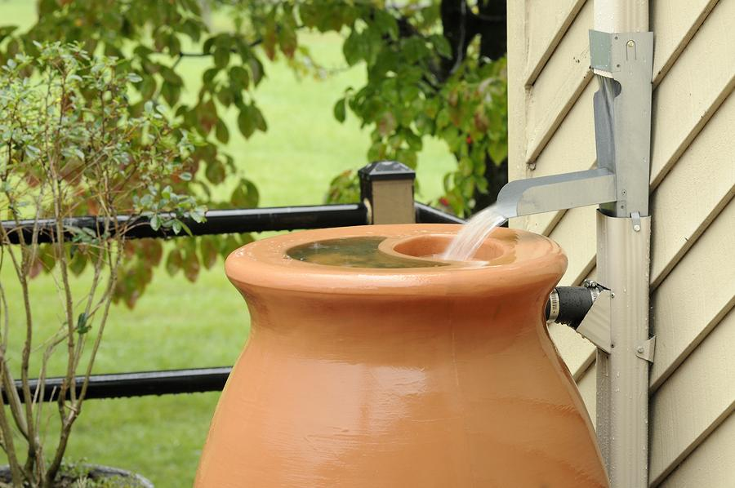 | Attaching a rain barrel to a downspout  {description of credit}
Creating a rain garden
{description of credit}
Planting a shade tree
{description of credit}
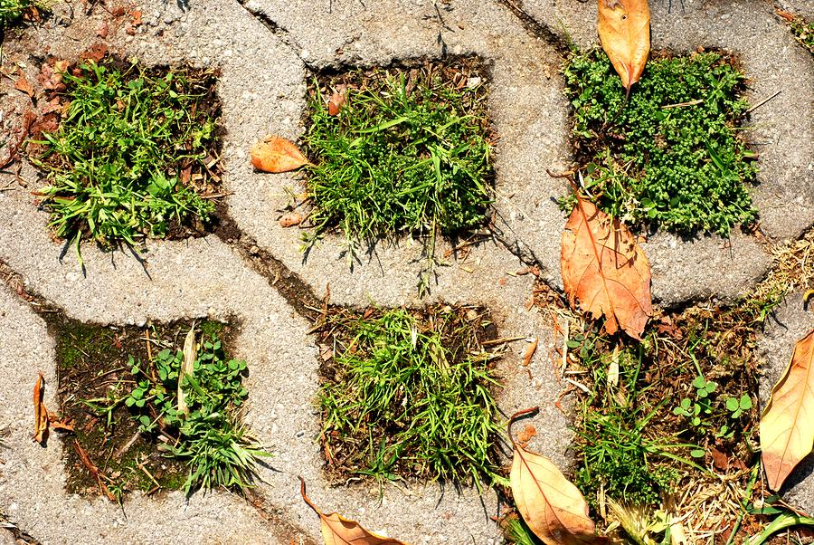 | Replacing asphalt with pervious pavement  {description of credit}
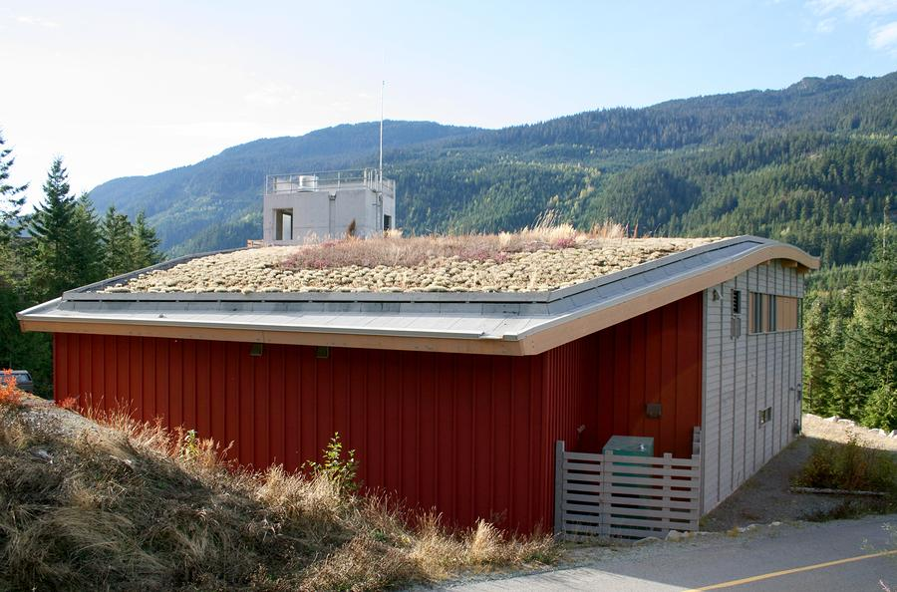 | Creating a green roof  {description of credit}

How do I pay my fee?
The fee is a line item on your water bill.

Who else has a program like this?
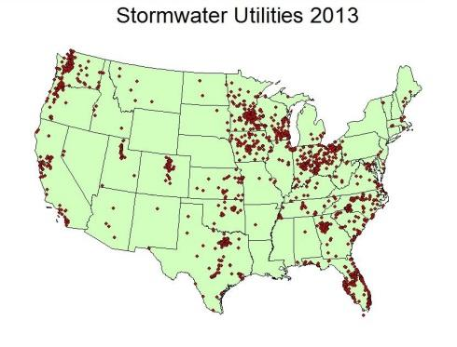
It is a trend for local governments across the country to institute programs like this. According to Western Kentucky University, more than 400 cities and counties have something similar in place. This number grows each year.
In 2013, the Pennsylvania legislature voted to allow townships, boroughs, counties, and cities to create Stormwater Authorities. Dozens of localities are now working to put these programs into place.

How can I learn more?
Visit www. to learn more. You will find a schedule of community meetings where you can personally ask questions of representatives of the stormwater authority.

Who Prepared This Sample FAQ?
Funding and content for this document (and the research that went into preparing it) was provided by:

